Graphical Stories

Below the following graphs are three stories about walking from your locker to your class.

Two of the stories correspond to the graphs. Match the graphs and the stories. Write stories for the other two graphs. Draw a graph that matches the third story.

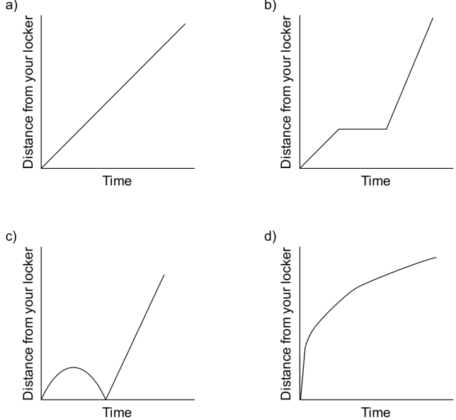
1. I started to walk to class, but I realized I had forgotten my notebook, so I went back to my locker and then I went quickly at a constant rate to class.

2. I was rushing to get to class when I realized I wasn’t really late, so I slowed down a bit.

3. I started walking at a steady, slow, constant rate to my class, and then, realizing I was late,
I ran the rest of the way at a steady, faster rate.

A Runner’s Run

Chris runs each day as part of his daily exercise. The graph shows his distance from home as he runs his route.
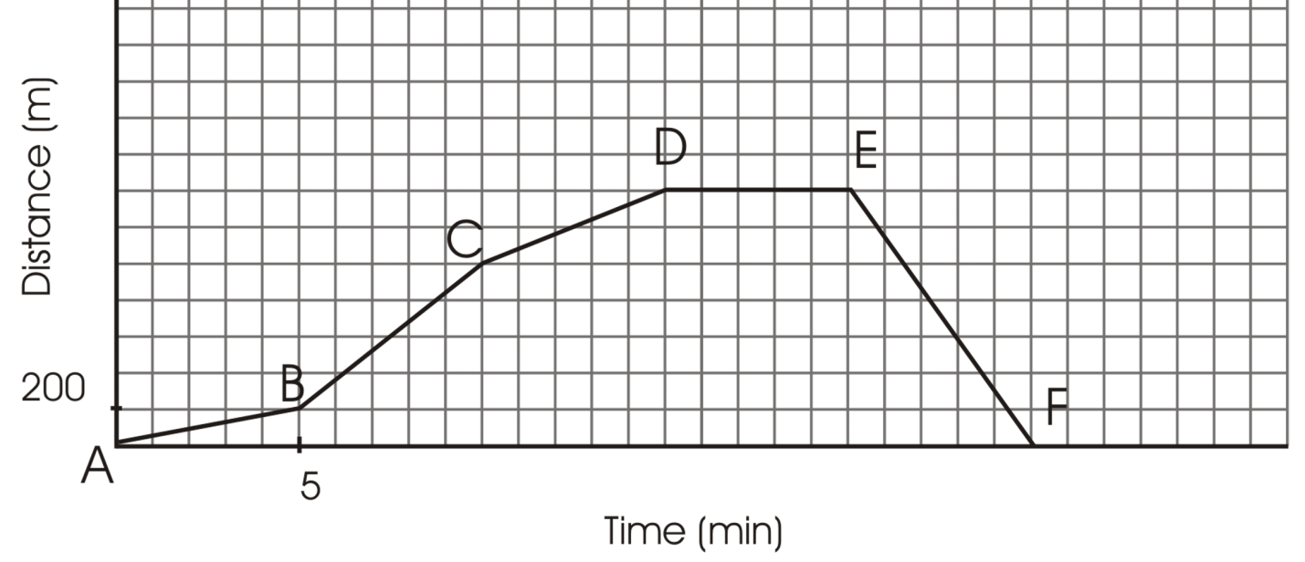
200

Calculate his rate of change (speed) for each segment of the graph

Models of Movement
4
8
12
16
20
24
28
32
36
40
44
48
100
200
300
400
500
600
700
Distance vs. Time
Time (min)
A
B
C
D
E
F
G
Distance from Home (m)

At 11 o’clock, Micha’s mother sends him to the corner store for milk and tells him to be back in 30 minutes. Examine the graph.

1. Calculate the rate of change (speed) of each of the line segments:

2. Why are some line segments on the graph steeper than others?

3. Over what interval(s) of time is Micha travelling the fastest? the slowest?
Compare steepness, not direction.

4. How long did it take Micha to reach the store? How do you know?

5. How long did Micha stay at the store?

6. How long did it take Micha to get home from the store?

7. How can you use the graph to tell which direction Micha is travelling?

8. Did Micha make it home in 30 minutes? How do you know?

9. Using the information the graph provides, write a story that describes Micha’s trip to the store and back.

