Scatterplots: Linear or Non-linear
Scatterplots: Linear OR Non linear

We have already seen that we can determine the type of relationship between the independent and dependent variables on a scatterplot.

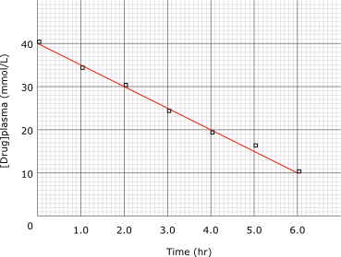
If there is a strong positive trend, or strong negative trend, we can place a line of best fit through the data. Since a line fits the data the best, the relationship is called a LINEAR relationship.

Sometimes, a curve fits the data better. Here the curve of best fit shows that the relationship is NOT linear. This type of relationship is called NON-LINEAR.
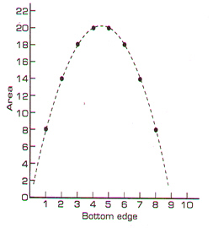

Remember that not all data has a relationship between the independent and dependent variables. When the trend is not strong, it can be more difficult to determine.
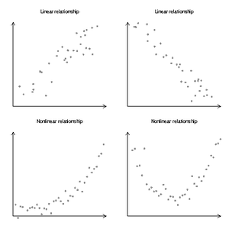
When you graph data in a scatterplot, you must determine
- Relationship or no relationship
- If a relationship: linear or non-linear
- Strong or weak
- Positive or negative

For each graph below:
- Identify the independent and dependent variables
- Identify if there is a trend in the data or no relationship
- If there is a trend in the data, is it linear or non-linear?
- Is the trend positive or negative? Strong or weak?
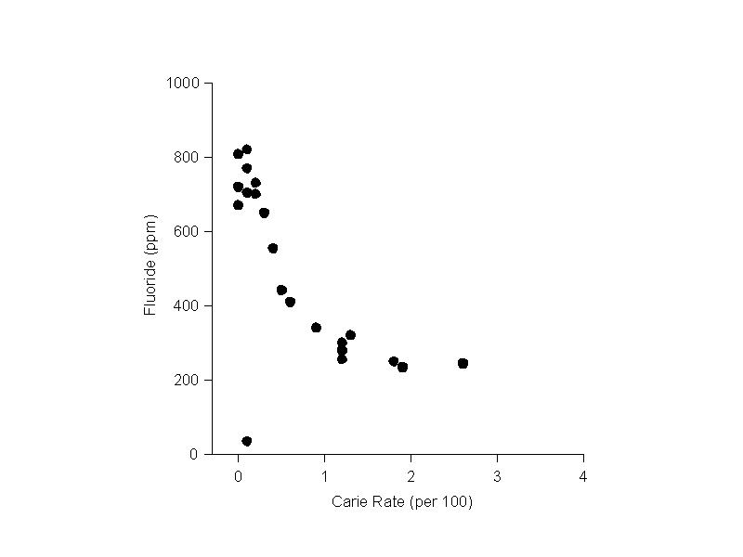
- Where there is a trend, place a line or curve of best fit

