Proteins

- Make up about 15% of the cell and have MANY functions
  - Enzymes, transport, structural, signaling, receptors, gene regulation

A molecule composed of amino acids linked together in a particular order specified by a gene’s DNA sequence – assembly by ribosomes.

The first protein to be sequenced was insulin, by Frederick Sanger, who won the Nobel Prize for this achievement in 1958.

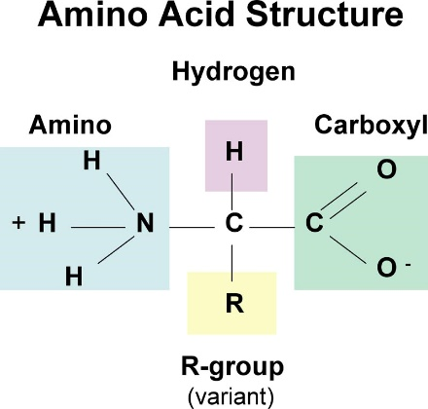

Peptide bonds hold the amino acids together in a protein.

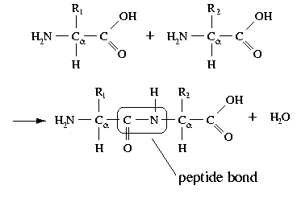

The shape of a protein determines its function. If the shape is altered the function is altered.

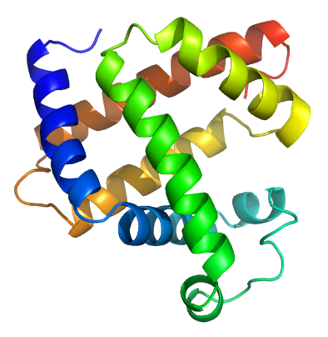
Proteins can have incredibly complex shapes.

Protein Shape is determined by:

Structure | Definition | 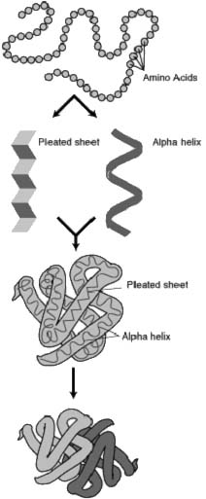 | Process
Primary | Order of Amino acids |  | Assembly
Secondary | The long chain can be pleated (folded) or coiled |  | Folding
Tertiary | The coiled, pleated chain is ‘squished’ and held together in a globular form. Weak Hydrogen bonds keep it in this shape. |  | Packing
Quarternary | Two or more tertiary structures are combined. Hemoglobin is 4 tertiary structures combined. |  | Interacting

Excess heat can destroy shape. This is called Denaturation.

Proteins are also necessary in animals' diets, since animals cannot synthesize all the amino acids they need and must obtain essential amino acids from food.

The nine amino acids humans cannot synthesize are phenylalanine, valine, threonine, tryptophan, methionine, leucine, isoleucine, lysine, and histidine.

Through the process of digestion, animals break down ingested protein into free amino acids that are then used in metabolism.

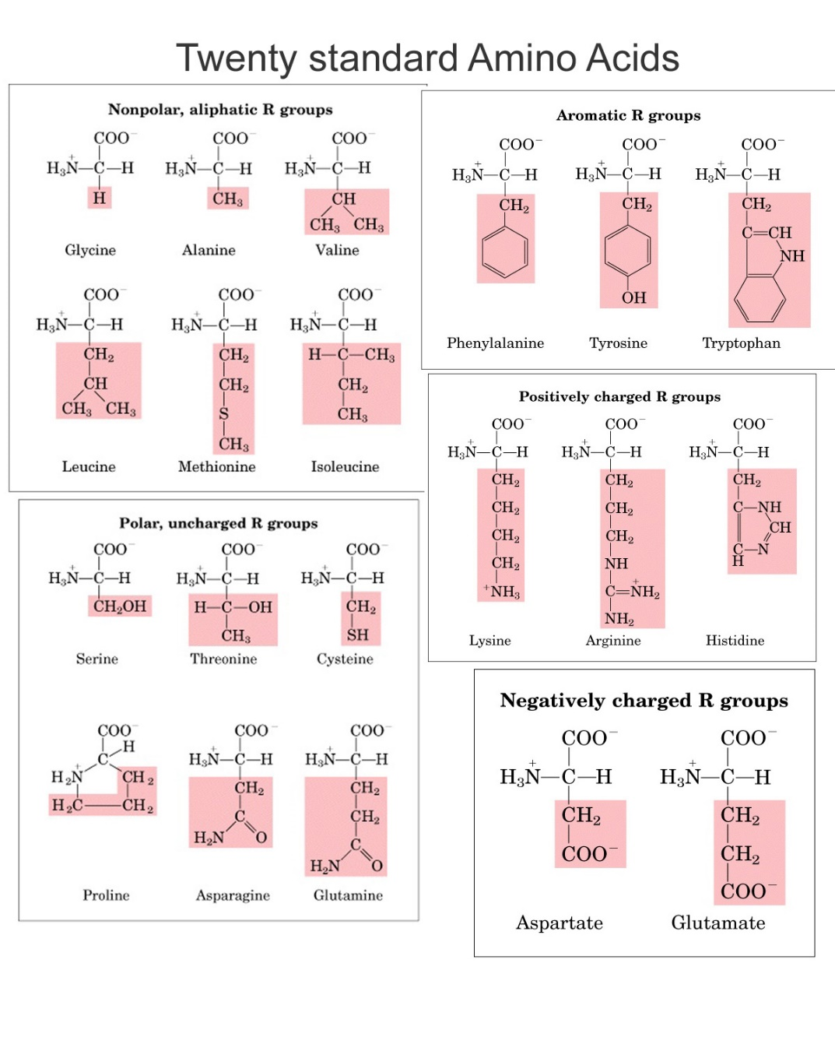

A molecule composed of amino acids linked together in a particular order specified by a gene’s DNA sequence – this transcription begins inside the nucleus where the _______________ transcribes (copies) the specific code required for the protein from the double stranded helix. This copy is called mRNA, which then gets carried out of the nucleus to a ribosome whose function is to assemble the protein. Each of the amino acids is linked to a 3 letter code (found in the mRNA), once matched up, the next a.a. comes in and links with a polypeptide bond and this continues until the protein is completed.

VIDEO of this

