# Additional Information Name and Date:__________________

**Mirages**

On a hot day, the air has is layered in different temperatures as you go up from the ground.

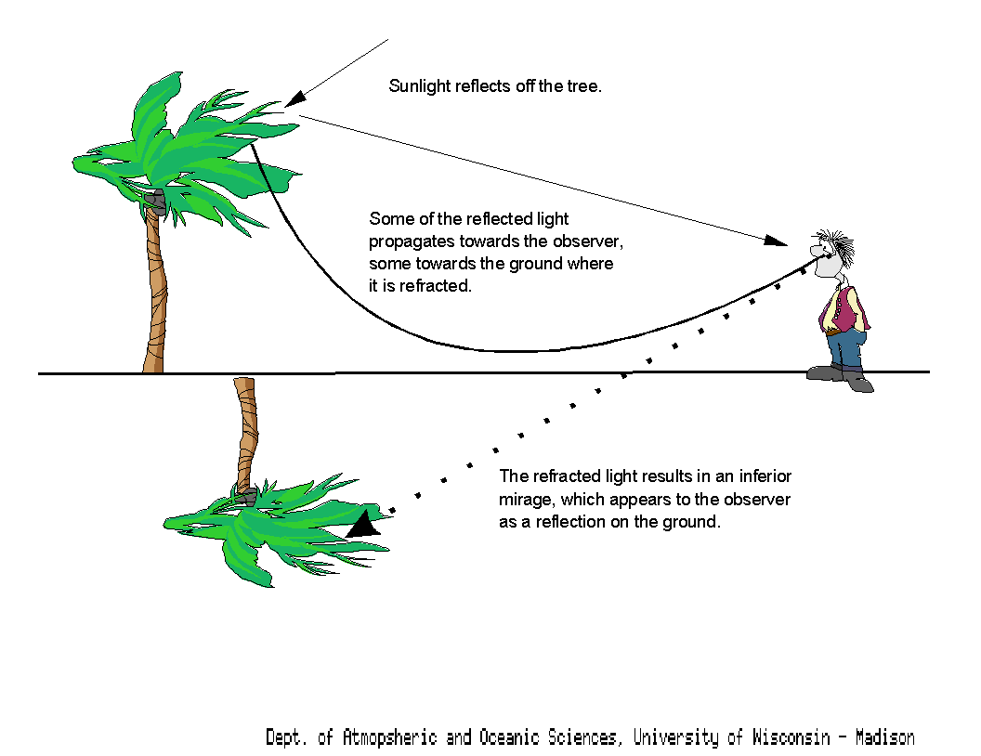Air of different temperatures has a different index of refraction so each layer bends light differently.

Eventually as the index of refraction changes, the critical angle is reached and the light is totally internally reflected.

We are conditioned to thing that light travels in straight lines so our eyes see a virtual image of the object below the ground. Since we have experienced water reflecting and not air, a mirage can make the road look wet.

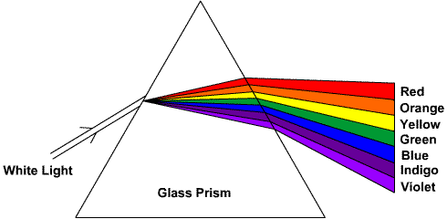**Dispersion**

Dispersion Is the refraction of white light into its separate wavelengths. The amount of refraction is different for each colour (wavelength). Certain materials like prisms and diamonds can split white light (visible light) into a rainbow!

<http://dev.physicslab.org/asp/applets/javaphysmath/java/totintrefl/default.asp>

**Additional Math problems**

1. Find the critical angle for light traveling from glycerine (n = 1.473) into water (n=1.33).
2. An object is 10 centimetres in height and is located at a distance of 25 centimeters from a double convex lens. The focal length is 8 centimeters. What is the image location and the height of the image.
3. The refractive index of the lens of the human eye is 1.41. If a ray of light goes from the air into the lens at an angle of 55°, what is the angle of refraction?
4. In an experiment, a block of cubic zirconia (n=2.16) is placed an unknown liquid. A laser beam is passed from an unknown substance through the cubic zirconia. The angle of incidence is 50°, and the angle of refraction is 27°. What is the index of refraction of this unknown substance?
5. What is the critical angle for water into air?
6. Suppose a diverging lens has a focal length of 10 cm, and an object of height 1 cm is placed in 10 cm from the lens. Locate the resulting image.
7. A convex rearview mirror has a radius of curvature of 16.0 m.

a. Determine the location of the image and its magnification for an object 10.0 m from the mirror.

b. How tall does a car (height = 1.6 m) appear through the rearview mirror when it is 10.0 m from the mirror?

1. The critical angle for a medium with air is 40.5°. What is the index of refraction of the medium?
2. A block of amber is placed in water and a laser beam travels from the water through the amber. The angle of incidence is 35° while the angle of refraction is 24°. What is the index of refraction of amber?
3. Find the sharpest angle that will allow total internal reflection in a fiber optic cable. The glass fiber has an index of refraction of 1.48, and the cladding (material that surrounds the fiber, similar to the insulation of a wire) has an index of refraction n = 1.46. We are looking for the critical angle. The light is traveling from the fiber to the cladding, so the fiber contains the incident ray, while the cladding contains the refracted ray.
4. An object (height =1.5 cm) is viewed through a concave spherical mirror (f=5 cm).

Determine the location, height and orientation of the image for the following distances the object is held away from the mirror.

a. do = 35 cm? b. do = 5 cm? c. do = 2 cm?

**Discussion Questions**

1. Light travels from medium A to medium B. The angle of refraction is greater than the angle of incidence. a) Which medium has the higher index of refraction? b) In which medium does the light travel at a lower speed?
2. Using your knowledge of refraction and the table of refraction indices, describe how you would identify an unknown, clear substance.
3. The index of refraction for blue light in glass is slightly higher than that for red light in glass. What does this indicate about a) the relative speeds of red light and blue light in glass, and b) the

angles of refraction for each colour for the same angle of incidence?

1. How does refraction lengthen a day at both sunrise and sunset?
2. To successfully spear a fish, you must aim below the apparent position of the fish. Explain.
3. In which medium does light travel faster, --one with a critical angle of 270 or one with a critical angle of 320 ? Explain. In both cases, air is the second medium.
4. I can not see the tails of these Orca, even if the water is crystal clear. However, I have no trouble looking down off the side of the boat and seeing a dolphin underwater. Use Physics terms to explain why.

