# Ray Tracing for Lenses

**The three principal rays for lenses are similar to those for mirrors:**

* ***The incident ray that runs parallel to the PA will refract through the principle focus***
* ***A incident ray that goes through the principle focus will refract parallel to the PA***
* ***The incident ray that goes through the optical center does not refract, assuming the lens is thin enough, it will not be deflected.*** 
  + ***This is the thin-lens approximation which we will see soon***

**Let’s Practice a couple:**

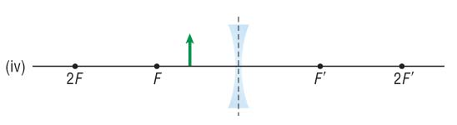

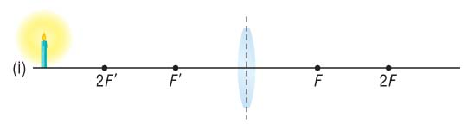

Try some yourself 

















